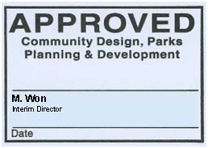Footer

**Insert Secondary Plan Area Name Here**

Brampton, Ontario

**Community Design Framework (CDF) Document**

Insert Conceptual Image(s) of Proposed Development Here



Submitted to the City of Brampton

Submission Number: 1st Submission, 2nd Submission, etc.

Date: DD/MM/YYYY

City File Number(s): X00X00.000

Subdivision File Number(s): 21T-00000B

Prepared by:

XYZ Limited, Landscape Architecture

ABC Limited, Architects

Prepared for:

Landowners’ Group Name

(123 Developments Ltd., X Properties Ltd., Y Homes Inc.)

OR Insert company logos.